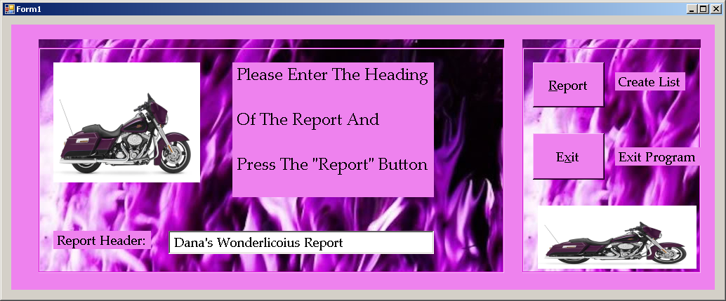

Dana Mills
IT310 GUI ; Programming with C++
TR 7:00 – 9:50 PM
Instructor: Renee Weather

Program Assignment III

Harley Company Product Inventory
Fall 2013

Dana Mills

00950777

Harley Company Product Inventory
Due Date: November 21, 2013

